**SIMULATION OF DELTA 3D PRINTER MACHINE**

**EXPT No : 5 DATE:**

**AIM:**

To simulate the construction of delta 3D printer and to get in-depth knowledge of mechatronics of delta 3D printer.

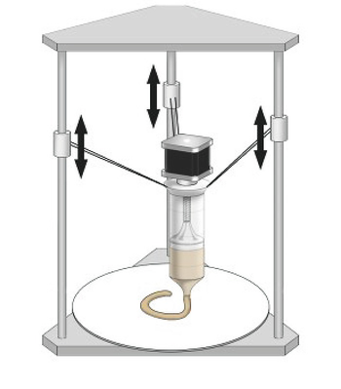

**REQUIREMENTS:**

* System - Windows 7 or higher, 1 GB RAM.

**PROCEDURE:**

**Assembly of Delta 3D Printer**

1. Select 'Assembly of Delta 3D Printer' from the visible list.
2. All the parts related to Delta 3D Printer will be shown on the screen.
3. Select the parts in sequence in which they are shown.
4. When the first part is selected then it will open in the blank space in the left side of the screen.
5. Further, when the correct part will be selected then it will get assembled with the previously selected part/parts.
6. If the user follows an incorrect sequence then a pop-up will appear on the screen showing the name of the part to be selected.

**Playing with Axes**

1. Move the z1-axis slider or enter the value (within the given range) in the given text box and press/select ENTER. Now observe the movement of the z1-axis assembly.
2. Move the z2-axis slider or enter the value (within the given range) in the given text box and press/select ENTER. Now observe the movement of the z2-axis assembly.
3. Move the z3-axis slider or enter the value (within the given range) in the given text box and press/select ENTER. Now observe the movement of the z3-axis assembly.

**OUTPUT:**

|  | Base :The base serves as a stable foundation, supporting the entire printer structure and providing a level surface for precise and accurate printing |
| --- | --- |
| Holder :The holder secures and positions various components such as the print head or sensors, ensuring their stability and precise movement along the printer's arms. |
| Rod :Rods in a delta 3D printer serve as structural elements, guiding the movement of the printer's carriages and arms, ensuring smooth and accurate motion during printing. |
| Top cover :The top cover in a delta 3D printer encloses the printing area, providing protection from external elements and maintaining a stable temperature for consistent print quality |
| Top cover frame :The top cover frame in a delta 3D printer supports the enclosure, maintaining its structural integrity and ensuring proper alignment for the cover. |
| Linear rail :Linear rails in a delta 3D printer facilitate smooth and precise movement of the printer's components, ensuring stability and accuracy during printing. |
| Motor :The motor in a delta 3D printer drives the movement of the carriages and arms, enabling controlled positioning for precise printing and layering. |
| Base :The base serves as a stable foundation, supporting the entire printer structure and providing a level surface for precise and accurate printing |
| Bed : The bed provides a levelled platform for print adhesion and stability, ensuring accurate layer deposition during the printing process. |
| Slide with connector :The slide with connector in a delta 3D printer assists in the smooth and coordinated movement of printer components, ensuring synchronized motion along the rails or arms |
| Connecting Rods :In a delta 3D printer, connecting rods link the moving parts, transmitting motion from the motors to the printer's arms. |
| Extruder :The extruder in a 3D printer melts and deposits filament, precisely controlling its flow to create the object's structure layer by layer. |
| Pins :Pins in a delta 3D printer are often used to secure and align various components, ensuring precise assembly and functionality of the printer's parts, such as connecting rods or joints. |
| Motor with gear :A motor with gears in a delta 3D printer facilitates controlled and precise movement by converting the motor's rotational force into specific, controlled motions along the printer's axes. |
| LCD :An LCD in a delta 3D printer serves as a user interface, allowing control over print parameters, monitoring progress, and providing access to printer settings directly from the machine. |

**Fig 1: Assembly of Delta 3D Printer**

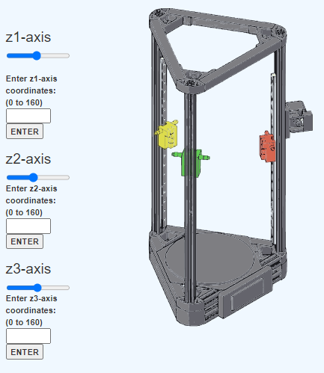

**Fig 2: Playing with axes**

**Result:** Thus the simulation on construction of delta 3D printer is completed & movement of axis along X, Y, & Z has been studied.